System Design

Data Flow Diagrams

A graphical tool used to describe and analyze the moment of data through a system manual or automated including the process, stores of data, and delays in the system. Data Flow Diagrams are the central tool and the basis from which other components are developed. The transformation of data from input to output, through processes, may be described logically and independently of the physical components associated with the system. The DFD is also know as a data flow graph or a bubble chart.
DFDs are the model of the proposed system. They clearly should show the requirements on which the new system should be built. Later during design activity this is taken as the basis for drawing the system’s structure charts. The Basic Notation used to create a DFD’s are as follows:
1. Dataflow: Data move in a specific direction from an origin to a destination.

2. Process: People, procedures, or devices that use or produce (Transform) Data. The physical component is not identified.

3. Source: External sources or destination of data, which may be People, programs, organizations or other entities.

4. Data Store: Here data are stored or referenced by a process in the System.

Context Level Data Flow Diagram
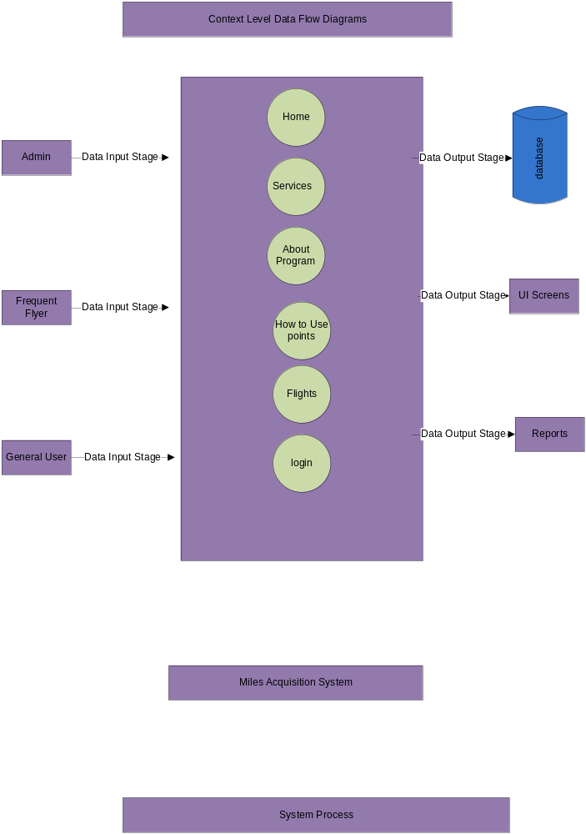
Level1 Data Flow Diagram For Frequent Flyer:

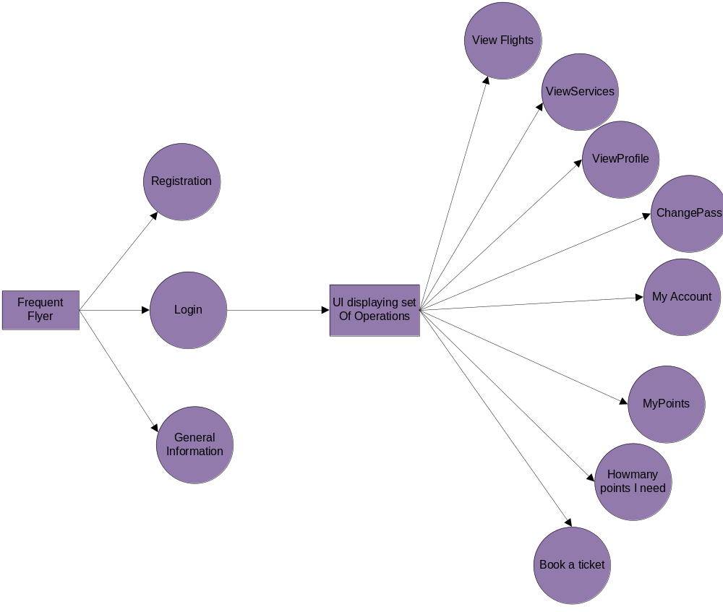

Level1 Data Flow Diagram for Administrator:

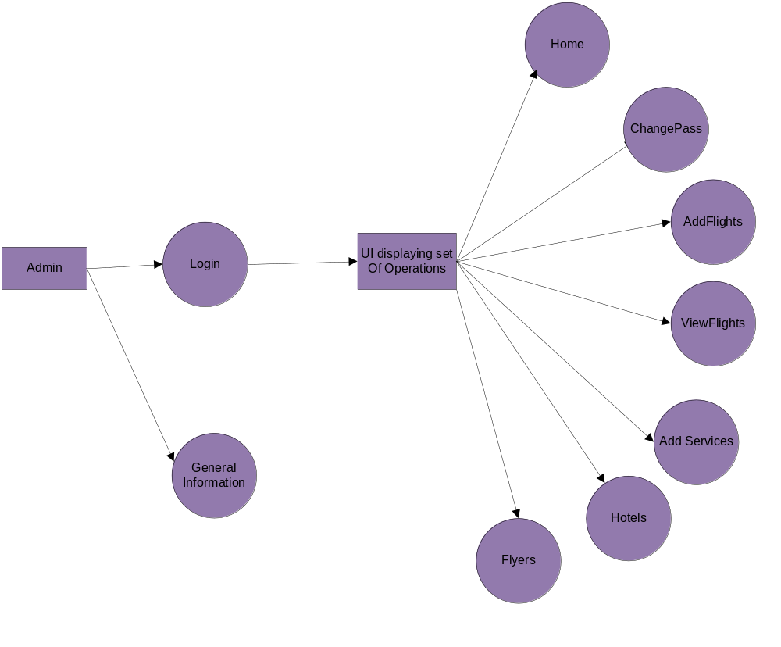

Level1 Data Flow Diagram for General User:

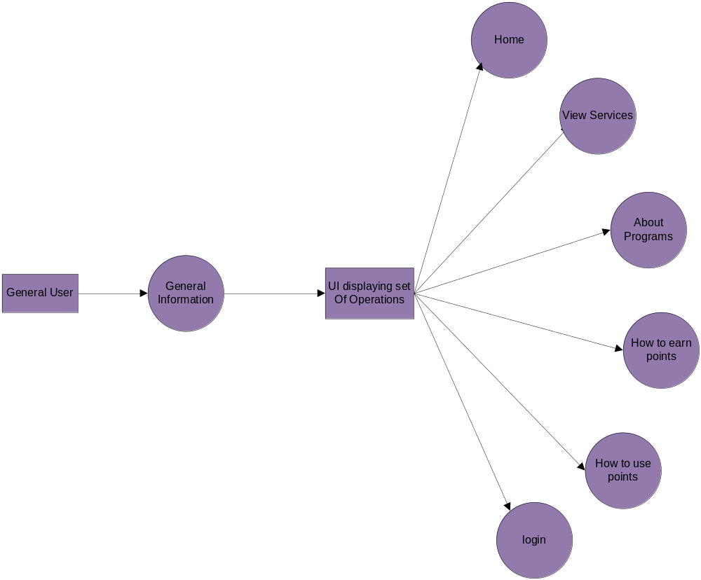

Authentication Data Flow Diagram:

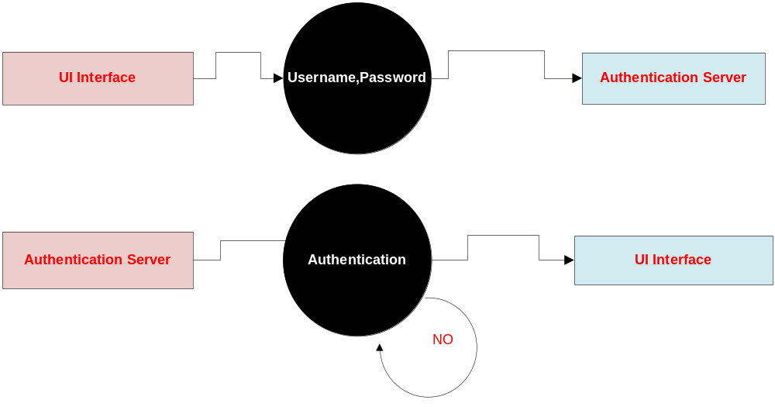

Admin:

Context Diagram Level Data Flow Diagram
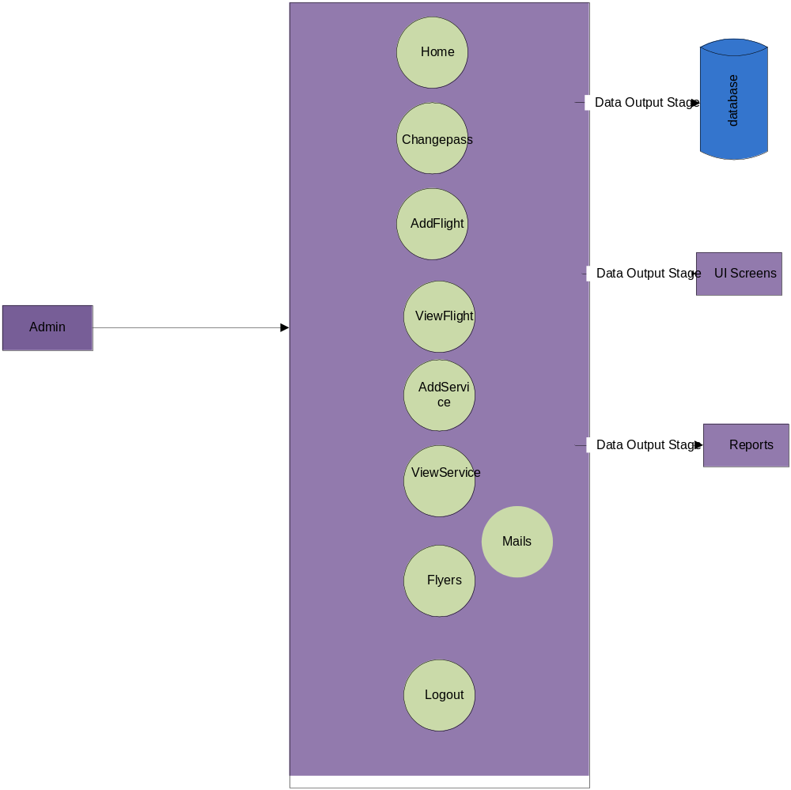

Frequent Flyer Context Level Data Flow Diagram Diagram
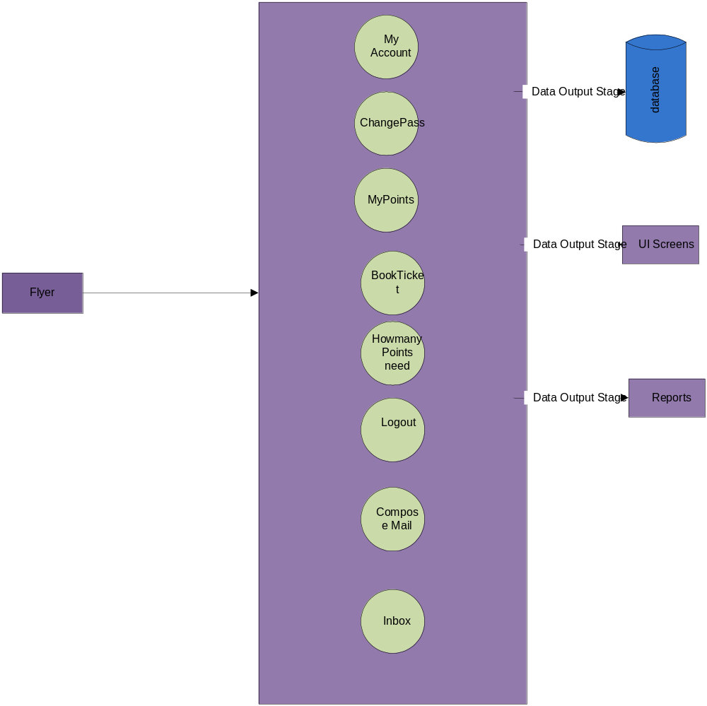

Level2 Data Flow Diagram:
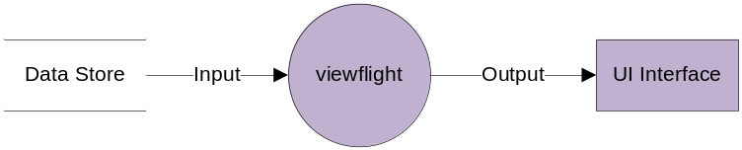

Level3 Data Flow Diagram:

